OUTLINE - Computer Systems Architecture for Black Box Implementation on a Delivery Drone

Group #2 - Juline A. Kerr, Debashis Jena, Ansoo Chang, Ken Kallon, Pablo Hernandez

University of Maryland Global Campus

ITEC 625 –Group Project - Dr. Steven Wright

October 13, 2019

PowerPoint DUE December 1, 2019

**Group Project Outline**

1. The Problem

Your team has been assembled to provide Information Technology consulting services to a newly formed fictitious company developing a commercial drone system for package delivery. While the CEO is optimistic for the success of the product based on some basic prototypes, the Chief Legal Officer (CLO) is concerned about product liability issues if the drones were to malfunction for any reason, and, citing pending regulatory reforms, has insisted that the team develop a "black box" capability to record the last 30 minutes of data from the flight operations computer and drone sensors - a similar role to the flight data recorder of commercial aircraft.

Your team was assembled by selecting individuals new to the company, so you have never worked together before. Also, the levels of experience and training for the various team members can be quite variable.

Your mission is to develop an overall computer systems architecture plan from top to bottom for the new "black box". This is an adjunct to the existing drone flight computer system and sensors.

1. Abstract

We have been tasked to create a black box system for our client, Company XYZ’s line of commercial package delivery drones. We must design a black box system that are durable and compatible with our client’s drone. For this to be deemed a successful project, a functional deliverable will be produced.

1. Purpose & Scope

The purpose of this project is to produce a deliverable that will address Company XYZ’s leadership concerns about product liability issues, from a consumer and regulatory standpoint. Our aim is to design and successfully deliver a fully functional monitoring device with black box capabilities for their commercial drone package delivery program.

1. Systems Architecture
2. Systems Hardware Architecture
   1. Structure, Housing, Reinforcement
      1. BB - Quality Framework – lightweight, carbon fiber, robust enough to survive a crash from low altitudes. You are not responsible for mechanical design, but should consider this in technology selection.
      2. BB - Wireless Reporting (Cloud Uploads) - periodically report back to base during normal operation via one of the cellular links.
      3. BB - Black Box - method to interface the "black box" with the main flight computer to capture its current state without significantly impacting the operation of the main flight computer.
   2. BB - Patents and ISO Quality Standards - identify if there are any patents or standards that you should consider in this design. The CLO has agreed that video other than from the direction of flight can be compressed to black and white SD levels to reduce storage demands.
   3. Both - Make commercially reasonable assumptions for any missing design parameters.
      1. Both - Consumer & Political Awareness – Consumers and Politicians made aware of the delivery drone operation plan for understanding of the cost-benefit ratio associated with their decisions. Flying Drone Bill of Rights
      2. Both - Police Awareness Plan
      3. Drone - Education & Certification for Drone Pilots – Drone Flight Simulation Regulation
      4. Drone - General Liability Insurance Policy - ISO 9001:2000 certification – QA certification
         * Shot from the Sky Recourse – Add to Insurance Policy
   4. External Interfaces Architecture - EXTERNAL - Structural Hardware Components - Parts List - <http://www.madehow.com/Volume-3/Black-Box.html>
      1. Drone - Frame with 6 Axis
         * What is body of black box?
      2. Drone - Chassis – Black Aluminum coated with Carbon Fiber
      3. Drone - Brushless Motor(s) & Motor Mount
      4. 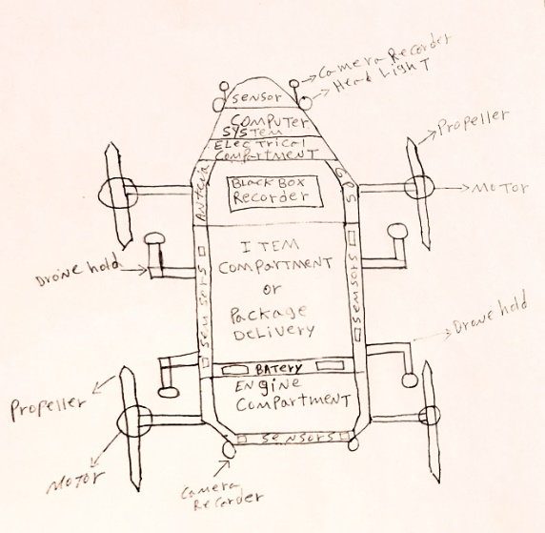(5) Rotor(s) with individual speed sensors
      5. Drone - (ESC) Electronic Speed Controls
      6. 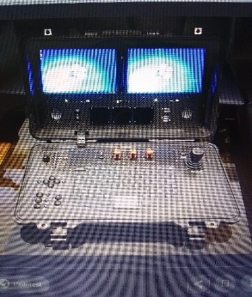Drone - Flight Controller
         * See Left Image
      7. Both - GPS & Gyroscope – Multiple Locations
         * What are the designated delivery locations?
         * Will the drone have pre-programmed conditional awareness configured? (i.e. lightning storms, signal jammers, bird attacks, etc.)
         * Need Weather Contingency Plan
         * Need programmed automated here-to-there delivery
         * Need predetermined fly-drive Capabilities – due to trees, porticos, awnings and overahngs, drone needs ability to land on open space and drive to delivery spot.
         * Crowded Skies Navigation System – some point in the future, more than 10,000 drones could be flying each day; avoid other drones and aircraft.
         * Need Invisible Fencing Parameters and Map for Programming
      8. Drone - Audio Sensor
      9. Drone - Two (2) LTE Data Sensors
      10. Drone - HD Video in Six (6) Axis
      11. Both - Radio Transmitter & Receiver
      12. Drone - Propellers
      13. Battery, Monitor & Charger - rechargeable / lithium battery
          * Docking, Loading & Charging System
      14. Drone - Pusher Props
      15. Drone - Retractable Landing Gear with Boom Arm
      16. Both - Reciever
      17. Drone - Antenna
      18. Drone - Gimbal, Gimbal Motor, Gimbal Controller Unit
      19. Both - Remote ID, or the ability to identify and establish ownership of a drone from a distance, is another area that will be key for the future, both for drone users and public safety officials.
      20. BB - Vehicular black box monitoring system
      21. Both - Cooler for the computer - What kind of temperature does the black box hold?
      22. Drone - Multiple Compartments (4) or (8) - capacity of carry – 1000lbs – digital sorter
      23. Drone - Bar Code Reader for Package Selection - Customer Receipt Scan – Phone App (Similar to FedEx Bar Code Scanner) – Apple/Windows/Google
      24. Drone - Signature Pad – Sign off by End User
      25. BB - Black boxes are fitted with an underwater locator beacon that starts emitting a pulse if its sensor touches water. They work to a depth of just over four kilometres, and can "ping" once a second for 30 days before the battery runs out. Log continuous data with Drone GPS. Integrate with Drone.
      26. Drone - Override Kill Switch
      27. Both - Need a consistent maintenance schedule? Education for Drone Maintenance & Repair



## System Software Architecture/Interface Architecture

* 1. Systems Software Architecture/Interface Architecture - INTERNAL - Embedded Computer System Architecture with Black Box – Parts List – Table Format - http://www.madehow.com/Volume-3/Black-Box.html
     1. CPU
     2. Drone - GPU
     3. Both - I/O
     4. Operating System Components for black box - Customized – which platform? With real-time feed for monitoring flight.
     5. Drone Operating System – Customized – which platform? With real-time feed for monitoring flight
     6. Drone - Programming for Grasp and Release Mechanisms
     7. Drone - Propeller Controls
     8. Drone - HD/SD Video Card
        + Cloud upload feedback - Save the data in the black box and also use AWS S3 or any other object based storage system for data storage incrementally - every 1 minute, stores videos or streaming data
     9. (PPT material) BlackBox Flight Data Recorder (FDR) –
        + SSD (Solid state drives) are to be used for data storage, because of their performance, capacity to save over 25 hours of data and ability to withstand major impacts.
        + The prime objective of the BlackBox is to record the flight data. The following parameters are recorded by the FDRs.
          - Time
          - Pressure altitude
          - Temperature
          - Airspeed
          - Vertical acceleration
          - Magnetic heading
          - Control-column position
          - Rudder-pedal position
          - Control-wheel position
          - Horizontal stabilizer
          - Battery status
          - GPS navigation data
     10. BB - Crash Survivable Memory Unit (CSMU) – Computing system with Save flight path (like google timeline) - Automated collision avoidance system. Comprehensive Collision Avoidance System with Airbag Crash Protection – buildings, power lines, trees, windmills, Christmas decorations and other UAV’s
     11. BB - Integrated Controller and Circuitry Board (ICB) - switchboard for the incoming data. – Computing system
     12. BB - Two (2) LTE Sensors Software - part for data communication - Signal processor of black-box for drone <https://patents.google.com/patent/KR20180125182A/en?q=Drone&q=Black&q=box&oq=Drone+Black+box>
     13. Both - Encrypt/Decrypt Data –
         + Need Privacy and Security Rules
         + Need Drone Spam Rules
         + <https://patents.google.com/?q=Black&q=box&oq=Black+box>
     14. Drone - An interface for the blackbox – like how can we access data physically from the blackbox (apart from transmitted data over LTE) or how to troubleshoot something
         + BB - What is the risk or GOP procedures of the black box?
         + Drone - Does the drone have vehicle and user licensing requirements?
     15. Both - Internal Temperature Control
     16. Both - Masking of Personal Data in direction of flight path - how to mask people’s face and vehicle registration plate numbers, if drone comes across any. (RISK)



1. Conclusion

Assume your audience is the CEO, CLO and the Chief designer of the main flight computer and they have all taken this class some time ago. You may consider this powerpoint as the means of presenting your conceptual plan. Use the computer system architecture components and analysis techniques discussed in class ( CPU, GPU, I/O, operating system components etc) as a basis for your discussion. Convince your management that you have done your due diligence and this design is feasible.

REFERENCES

<http://www.madehow.com/Volume-3/Black-Box.html>

Possible Patent of drones in USA, google patent

<https://patents.google.com/?q=Black&q=box&oq=Black+box>

**Time-Sheet Template**

**ALL TEAM MEMBERS (WEEKLY) – Due Sunday’s by 11:59p EST**

Starting with Week 3, at the end of each week, each Group Member may be required to complete the attached Time-Sheet and submit it in the Group Conference in a post named "Week xxx Time-Sheet for <your name>." Each Group Member should review the submitted Time-Sheets and speak up in case discrepancies are encountered.

**Project Outline and Schedule Template – JULUNE KERR**

Please make sure to have at the end of Week 4 Project Outline and Schedule. You can use the provided template and post it in your Group area. It is not graded, but should help organize your group work.

**Status Report Template**

**ALL TEAM MEMBERS (WEEKLY) – Due Sunday’s by 11:59p EST**

To help you further organize your group work, you may use the attached template and post in your group conferences a Status Report. The report should identify any schedule issues, risks, or communication problems. Please be honest, concrete, and quantitative. If there is a problem, please notify me so that we to take corrective actions.

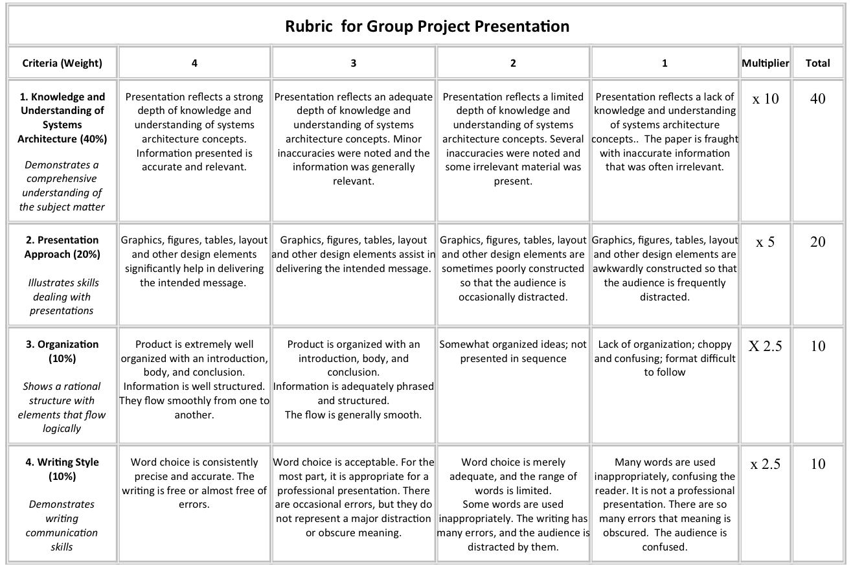RUBRICS

